Name:__________________________________

/20

**HEATING AND COOLING LAB VALIDATION QUIZ**

Specific Heat of Nickel Experiment

1. Bill and Susan set up their equipment to heat their nickel pellets as below. Susan suggests that there are several things wrong with this initial set up. List two major errors in the table below which may give invalid readings. Include explanations as to **why** you think that the errors or perceived errors will produce invalid data.

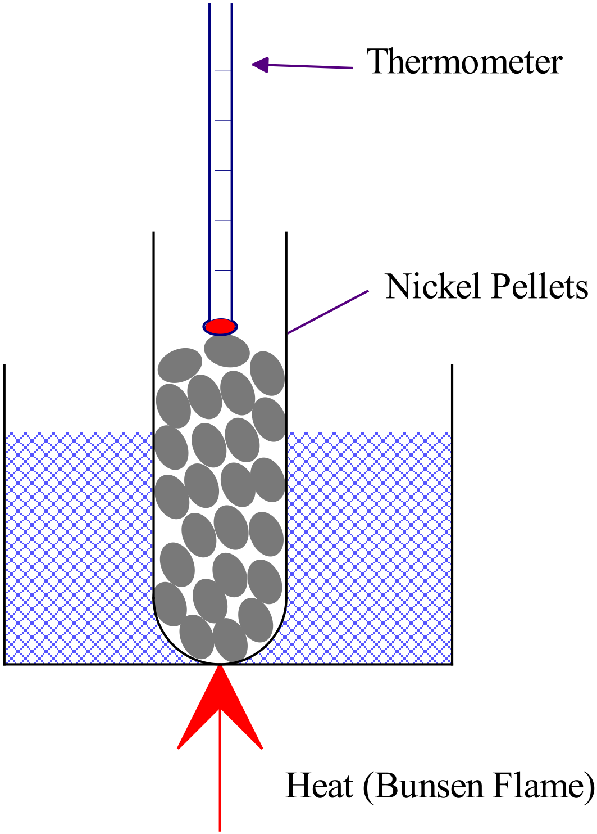

|  |  |
| --- | --- |
| Perceived Error | Explanation |
| 1. Ni not fully immersed in water bath. 2. Thermometer not in right place. 3. Heat applied too close to Ni | Ni pellets at the top will not be at the required uniform temperature as the rest of the pellets/water (they will be colder)  Thermometer should be immersed within the Ni pellets (if they are small enough) or else in the water bath.  Ni pellets at the bottom will not be at the required uniform temperature as the rest of the pellets/water (they will be hotter) |
|  | **(any 2 responses) ✓✓** |

(4)

1. During the experiment, Bill followed the instructions and heated the water bath to 90·0 °C. He then quickly put the test tube containing the dry nickel pellets, which were initially at room temperature, into the water bath and timed 1 minute while they heated. The pellets remained dry. Bill then removed the test tube containing the nickel pellets and quickly but carefully poured the pellets into the receiving water. He then measured the rise in temperature of the receiving water. He stirred gently a couple of times and took a reading as soon as the water had stopped rising in temperature.
2. What is the major flaw in Bill’s procedure? What effect would this have on the value for specific heat capacity he determined from his experiment? Explain.

(2)

*Pellets were not in the water bath long enough to be confident that they had reached a uniform temperature with the water.* ***✓***

*This will result in an overestimate of the real temperature of the Ni pellets and therefore the actual temp change.*

*Since c = Q/(ΔT m), an exaggerated value for ΔT will* ***underestimate*** *specific heat* ***✓***

1. If Bill used the same thermometer to measure the temperature of the heating bath and the receiving water, what effect would this have on the specific heat capacity determined? Explain

(2)

*The thermometer will transfer heat to the calorimeter.* ***✓✓***

*(This will over-estimate the heat capacity of the Ni, since the calculation assumes that all the heat comes from the Ni sample)*

1. Alex and Rory apply their new found knowledge to calculate the specific heat of a recently discovered metal called Bradburium. Use the boys’ data as listed below to determine the specific heat capacity of Bradburium. Assume that no energy is transferred to the calorimeter or the environment. Show neat and full working.

Given Information

* mass of Bradburium sample = 57·26 g
* mass of receiving water = 45·0 g
* initial temp of Bradburium = 93·0 °C
* initial temp of receiving water = 19·0 °C
* final temp of receiving water and Bradburium = 23·0 °C

(4)

*Heat into water = heat out of metal*

**✓**

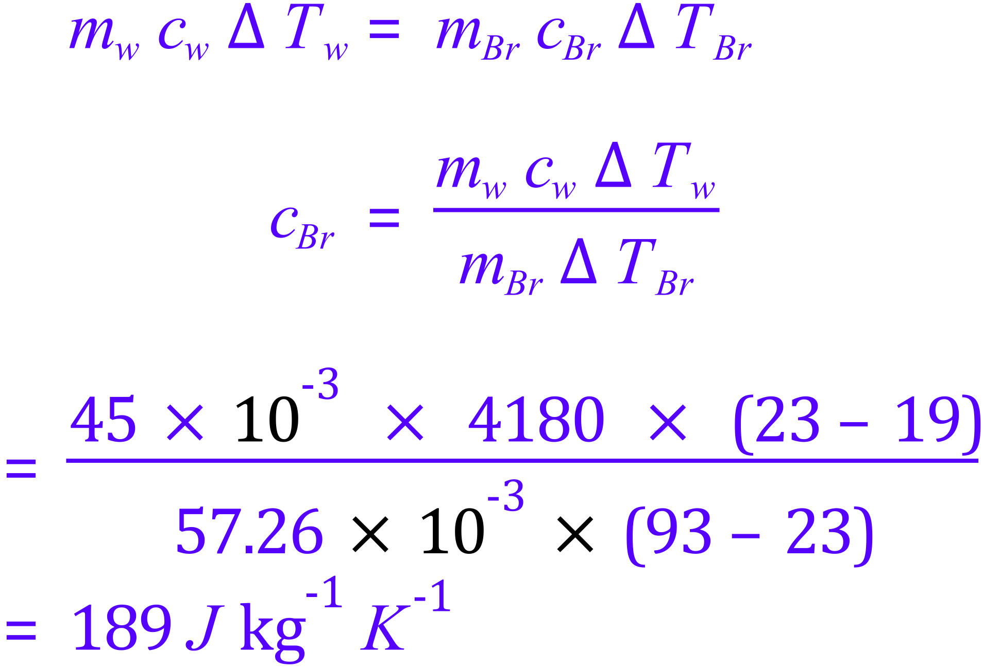

**✓**

**✓**

**✓**

Latent Heat of Fusion of Ice Experiment

1. If you used an aluminium calorimeter (c = 900 J kg-1 K-1) of the same mass as the copper calorimeter (c = 390 J kg-1 K-1) you used in your experiment, would you need; **more, the same or less** ice (*circle your response below*) to attain the same final temperature of the water as you achieved with the copper calorimeter? With reference to the equation for Qgained, explain your choice.

(2)

**MORE** THE SAME LESS



*Where “cal” = calorimeter*

*If the calorimeter is aluminium then it has a higher spec. heat capacity (ccal). With all other terms the same, the overall heat will need to be more to achieve the same final temperature.*

1. Michelle and Shirley carried out the Latent Heat of Fusion experiment, but realised afterward that they had made some mistakes. Their freezer (holding the ice) runs at −4·00 °C . As soon as the ice appeared wet, they started the experiment.
2. Explain how the ice can be wet, yet still be below zero degrees Celsius.

(1)

*A temperature gradient is present in the ice. The temp at the outside can be zero, but it can be colder on the inside.*

To check the effect of this error, they decide to calculate the heat gained by the ice using a mean temperature of minus 2·00 °C for the ice (instead of 0 °C).

However, they also realise that they forgot to dry the ice and that the water film on the ice would account for approximately 1·0% of the total measured “ice mass”.

Use the girls’ data to calculate the total thermal energy gained by the 21·75 g of “measured ice” when a final water temperature of 3·00 °C is achieved, using the accepted values of specific heat capacities and latent heat of fusion for water.

Show full working used to obtain your answer below.

(4)

Simple treatment (neglects the presence of the 1% water). Still worth full marks:

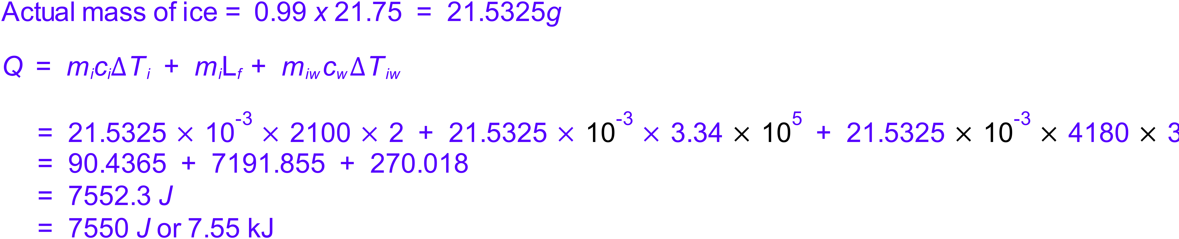

**✓**

**✓**

**✓**

**✓**

Because the water film must still on the ice when it’s dropped in the water, it will also need to be warmed to 2 degrees, which gives a slightly different answer:

